Name _______________________ Mr. Taylor-Waldman
Class Section ______________

Unit 3 Test Review: Atoms, Electricity, and the Periodic Table of Elements

→ Fully completed review sheets can be handed in on the day of the test (Wednesday, March 2) for three points extra credit. All blanks must be filled in, and all review questions must be answered completely.

Atoms and the Periodic Table

Chapter 3, Section 1: Introduction to Atoms (CBB pages 74-79)

Terms
atom: smallest unit of any element or type of matter
proton: positively charged particle located ___________________.
neutron: neutrally charged particle located in the nucleus
electron: ___________________ charged particle orbiting in a field around the nucleus
atomic number: the number of protons in an atom
mass number: the sum of ___________________ and neutrons in an atom’s nucleus
isotope: atoms with the same number of protons but a different number of _______________.

Important Concepts
1. Protons and neutrons account for most of an atom’s mass, while electrons account for most of an atom’s ___________________.
2. The mass of 1 proton = 1 neutron = approximately _________________electrons.
3. In a normal stable atom, the number of protons is the same as the number of electrons.
4. ________________ is the flow of energy through electrons.

Chapter 3, Section 2: Organizing the Elements (pages 80-87)

Terms
atomic mass: the ______________ __________ of all of the isotopes in an element’s atoms.
period: a horizontal row of elements in the periodic table
group: a vertical column of elements in the periodic table

Important Concepts
1. The properties of the elements change in a predictable way as you move from left to right across the periodic table
2. The elements in each group have properties than are the same.
3. The modern periodic table is organized in order of increasing __________ ____________, while Mendeleev’s original periodic table was organized by increasing atomic mass.

Chapter 3, Section 3: Metals (pages 88-95)

Terms
malleability: material that can be bent, hammered, or rolled into flat sheets
ductility: material that can be pulled out or drawn into long wires.
conductivity: the ability of a substance to transfer heat or ___________________
reactivity: the ease and speed with which an element reacts with other elements or compounds

Important Concepts
1. Elements are classified as metals based on their physical and chemical properties
2. The reactivity of metals ___________________ as you move across the periodic table from left to right
3. Elements with an atomic number higher than radium (#92) are created synthetically, through the use of ___________________
4. Know the basic properties and locations in the periodic table of the following metal groups: alkali metals (group 1), alkali earth metals (group 2), transition metals, lanthanides, actinides

Chapter 3, Section 4: Nonmetals and Metalloids (pages 98-105)

Terms
nonmetal: an element that lacks the properties of metals and is a bad conductor of electricity and ______________.
metalloid: an element with properties of both metals and nonmetals
semiconductor: an element with a varying ability to conduct electricity (acts like a “switch”)

Important Concepts
1. The most useful property of metalloids is their varying ability to conduct electricity.
2. Group 17 (halogens) are highly reactive nonmetals, and group 18 (noble gases) are unreactive

Electricity

Stem Lab #5: Building a Light Stick

Terms
battery: a power source that uses a chemical reaction to separate electrons and build up a positive and negative charge in order to produce an electrical current
LED: light-emitting diode - type of light bulb where electricity flows in only ____ _____________
post: positive and longer side of an LED
anvil: negative and shorter side of an LED
conductor: a material that easily transfers electricity
insulator: a material that resists and stops the flow of electricity

Important Concepts
1. In a(n) ___________ circuit, electricity can flow without interruption, but in a(n)___________ circuit there is a break in the flow of electricity.
2. Current is measured in Amps. 1 Amp is 6.241 x 10¹⁸ electrons (1 coulomb) per second going through the wire.
3. A measure of a battery’s total storage or “life” is measured in Amp Hours (Ah).
4. A battery with 20 Amp Hours will produce 20 Amps for 1 hour, or 10 Amps for ___ hours.

Ohm’s Law: Voltage, Current, and Resistance

Terms
voltage (V): amount of pressure or force causing a flow of electrons, measured in volts
current (I): measure of the _________ of electrical flow. measured in amps
resistance (R): opposition to current flow, measured in ohms Ω
Ohm’s law: a law relating the voltage, current, and resistance in an electrical circuit.

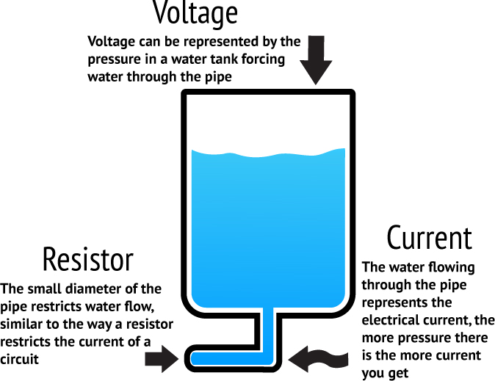
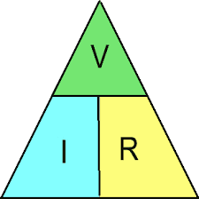

Important Concepts
1. Make sure you understand the “water analogy” in the picture above, which describes the relationship between voltage, resistance and current.
2. Voltage, current, and resistance can all be calculated using the simple equations illustrated in the triangle above.

Stem Lab #6: Building Circuits

Terms
series circuit: a circuit through which electricity can only flow in one path
parallel circuit: a circuit through which electricity is able to flow in multiple paths
voltmeter: a device used to measure the voltage of a circuit or power source
ammeter: a device used to measure the _____________ in a circuit.

Important Concepts
1. In a ___________ circuit, if one part of the circuit is disconnected, the entire circuit loses electricity.
2. Series circuits divide the battery’s voltage across all loads (lamps)
3. Voltage does not decrease in a parallel circuit when more loads are added.
4. Know how to describe, in detail, how to use a voltmeter and ammeter.

Review Questions
1. What are the charges and locations of the three subatomic particles?

2. What is an isotope?

3. What is an atom’s mass number?

4. What is an atom’s atomic mass, and why does it usually end in a decimal?

5. How many proton and neutrons are in the following isotopes (use your textbook or an online periodic table to find the atomic number of each element)?

- Copper–57 b) Tin–102 c) Iron–55 d)Aluminum–28
6. Identify and explain the physical property of metals that relates to electricity.

7. How did Mendeleev organize his periodic table, and how is the modern table organized?

8. How do the properties of metals change from left to right across the periodic table, and why does this happen?

9. Describe as much as you can about the element that you wrote about and researched for the element project.

10. Explain three different aspects of electricity that you learned from either STEM LaB # 5 (Building a Light Stick), STEM Lab #6 (Circuit Building) or STEM Lab #7 (Squishy Circuits)

11. What are synthetic elements, and how are they created?

12. What is a nonmetal and how does it react?

13. What is one property of metalloids and what type of device can metalloids such as silicon be used to produce?

14. What is the difference between an insulator and a conductor? What kind of elements are good conductors of electricity, and which are good insulators?

15. What is the difference between a parallel and a series circuit? What would happen if you disconnected one bulb from a 4-bulb series circuit? What would happen if you disconnect one bulb from a 4-bulb parallel circuit?

16. An alarm clock draws 0.5 A of current when connected to a 120 volt circuit. Calculate its resistance.

17. An electric heater works by passing a current of 100 A though a coiled metal wire, making it red hot. If the resistance of the wire is 1.1 ohms, what voltage must be applied to it?

18. A 12 volt car battery pushes charge through the headlight circuit with a resistance of 10 ohms. How much current is passing through the circuit?
19. You have a large flashlight that takes 4 D-cell batteries. If the current in the flashlight is 2 amps, what is the resistance of the light bulb? (Hint: A D-cell battery has 1.5 volts.)

20. Thinking back to the last two STEM labs on building series and parallel circuits, discuss the differences that you observed in bulb brightness, voltage, and current. What changed in the series circuit when you switched from two bulbs to four bulbs. Make the same comparison for the parallel circuit when you increased the number of bulbs. Explain your observations based on your understanding of voltage, current, resistance, and Ohm’s Law.

Use the four circuit boards below to answer the remaining questions.

21. Which board shows a 3-bulb series circuit? ______

22. Which board shows a parallel circuit? ______

23. Describe two different problems with the setup in board D.

24. Which board would have the brightest bulbs? Which would have the dimmest?

